**MY BIKE LIST :**

1. 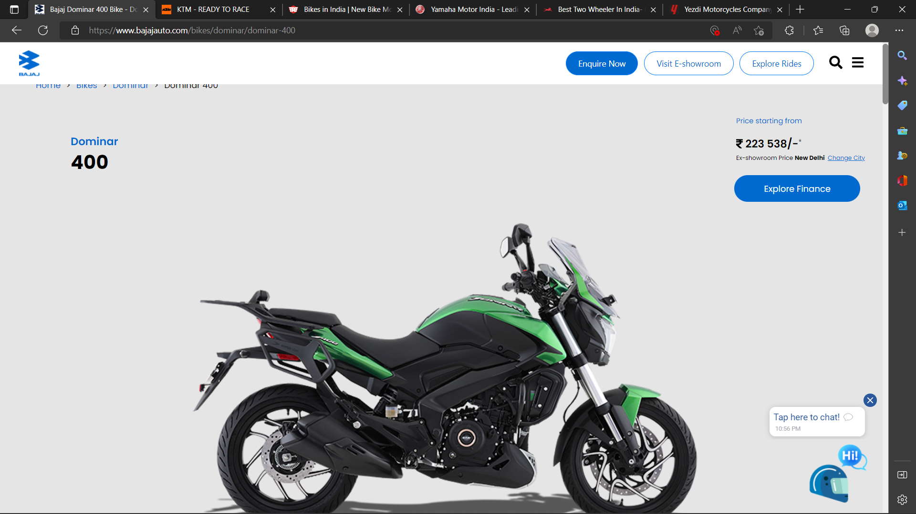

**BAJAJ DOMINAR 400 SPECIFICATIONS**[Explore Model](https://www.bajajauto.com/bikes/dominar/dominar-400)

**ENGINE**

|  |  |
| --- | --- |
| **Type** | Single cylinder, 4 stroke, DOHC, 4 Valve, Liquid Cooled, Triple Spark, FI |
| **Displacement** | 373.3 cc |
| **Max Power** | 29.4 kW (40 PS) @ 8800 rpm |
| **Max Torque** | 35 Nm @ 6500 rpm |
| **Clutch** | Wet, Multiplate with Assist & Slipper Clutch |
| **Gearbox** | 6 Speed |

**CHASSIS & SUSPENSION**

|  |  |
| --- | --- |
| **Frame** | Beam type perimeter frame |
| **Front Suspension** | Telescopic, 43 mm USD Fork, 135 mm travel |
| **Rear Suspension** | Multi-step adjustable Mono shock with Nitrox, Wheel stroke of 110 mm |

**BRAKES & TYRES**

|  |  |
| --- | --- |
| **Brakes front (type & size)** | ABS, 320 mm dia disc |
| **Brakes rear (type & size)** | ABS, 230 mm dia disc |
| **Tyres front** | 110/70-17 Radial |
| **Tyres rear** | 150/60-17 Radial |

**DIMENSIONS**

|  |  |
| --- | --- |
| **L X W X H** | 2156 mm X 863 mm X 1243 mm |
| **Wheelbase** | 1453 mm |
| **Ground clearance** | 157 mm |
| **Kerb weight** | 193 kg |
| **Fuel capacity** | 13 L |

**ELECTRICALS**

|  |  |
| --- | --- |
| **Battery** | 12V, 8Ah VRLA |
| **Headlamp** | Full LED with Auto Headlamp On (AHO) |
| **Speedometer** | Digital Split Console |
| **Gear Indicator** | Yes |
| **Trip Indicator** | Yes (Time, Average Speed, Fuel) |

1. 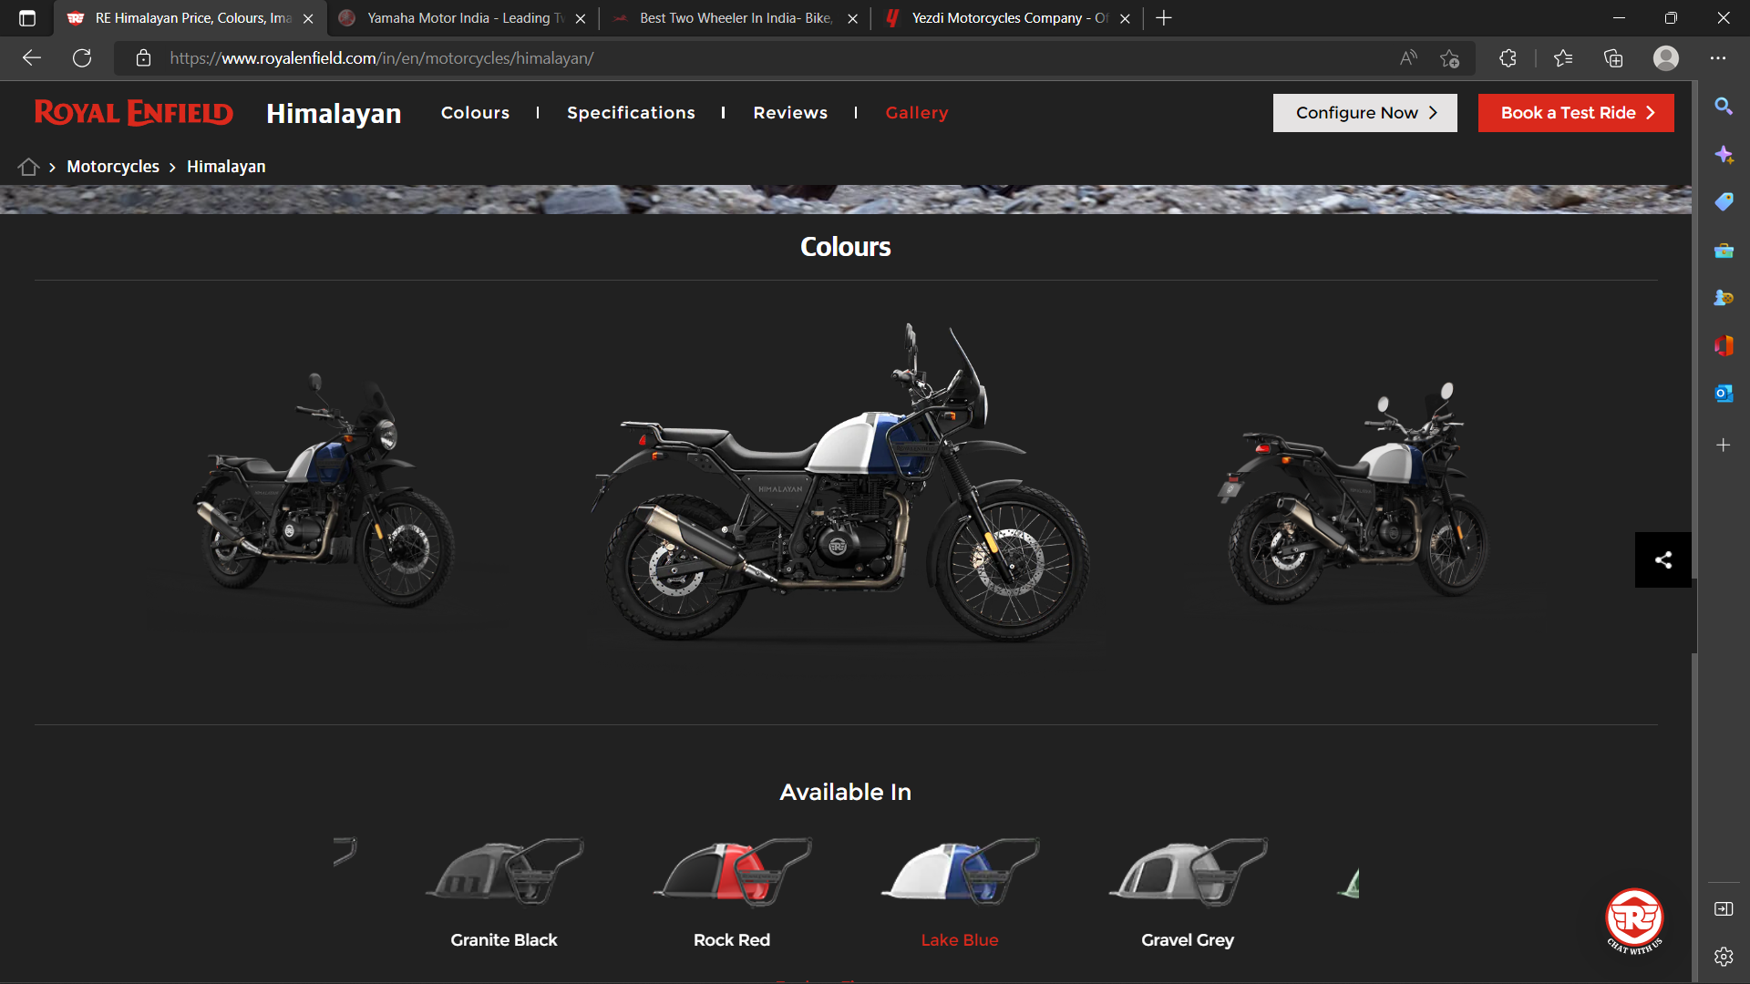
2. Features

|  |  |
| --- | --- |
| Body Type | Adventure Tourer Bikes, Tourer Bikes, Off Road Bikes |
| ABS | Dual Channel |
| Seat Type | Single |
| Starting | Self Start Only |
| Pass Switch | Yes |
| Speedometer | Analogue |
| Tachometer | Analogue |
| Trip Meter | Digital |
| Average Fuel economy | Yes |
| Low Fuel Warning Lamp | Yes |
| Stepup Seat | Yes |
| Passenger Footrest | Yes |
| Cooling System | Air Cooled |
| Odometer | Digital |
| Navigation | Yes |
| Switchable ABS | Yes |

Features

|  |  |
| --- | --- |
| Body Type | Adventure Tourer Bikes, Tourer Bikes, Off Road Bikes |
| ABS | Dual Channel |
| Seat Type | Single |
| Starting | Self Start Only |
| Pass Switch | Yes |
| Speedometer | Analogue |
| Tachometer | Analogue |
| Trip Meter | Digital |
| Average Fuel economy | Yes |
| Low Fuel Warning Lamp | Yes |
| Stepup Seat | Yes |
| Passenger Footrest | Yes |
| Cooling System | Air Cooled |
| Odometer | Digital |
| Navigation | Yes |
| Switchable ABS | Yes |

Transmission

|  |  |
| --- | --- |
| No Of Gears | 5 Speed |
| Transmission | Manual |

Brakes

|  |  |
| --- | --- |
| Brakes Front | Disc |
| Brakes Rear | Disc |

Performance and Fuel economy

|  |  |
| --- | --- |
| Braking (100-0 kmph) | 53.25m |
| Braking (80-0 kmph) | 33.57m |
| Mileage (Highway) | 39.96 kmpl |
| Braking (60-0 kmph) | 19.43m |
| Mileage (City) | 32.04 kmpl |

Tyres and Wheels

|  |  |
| --- | --- |
| Tyre Size | Front :-90/90-21 Rear :-120/90-17 |
| Wheel Size | Front :-533.4 mm,Rear :-431.8 mm |
| Radial Tyre | Yes |
| Tyre Type | Tube |
| Wheels Type (Pressed Steel/ Alloy) | Spoke |

Dimensions

|  |  |
| --- | --- |
| Seat height | 800 mm |
| Length*Width*Height | 2190*840*1370 mm3 |
| Wheelbase | 1465 mm |
| Length | 2190 mm |
| Height | 1370 mm |
| Ground Clearance | 220 mm |
| Width | 840 mm |
| Fuel Capacity | 15+/- 0.5 Liters |
| Kerb Weight | 199 Kg |
| Tail Light | LED |
| Front Brake Diameter | 300 mm |
| Rear Brake Diameter | 240 mm |

Electricals

|  |  |
| --- | --- |
| Battery Type | VRLA |
| Battery Capacity | 12 V/8 Ah |
| LED tail lights | Yes |
| Turn Signal Lamp | Bulb |
| Charging at Home | Not Available in Himalayan |
| Charging at Charging Station | Not Available in Himalayan |

1. 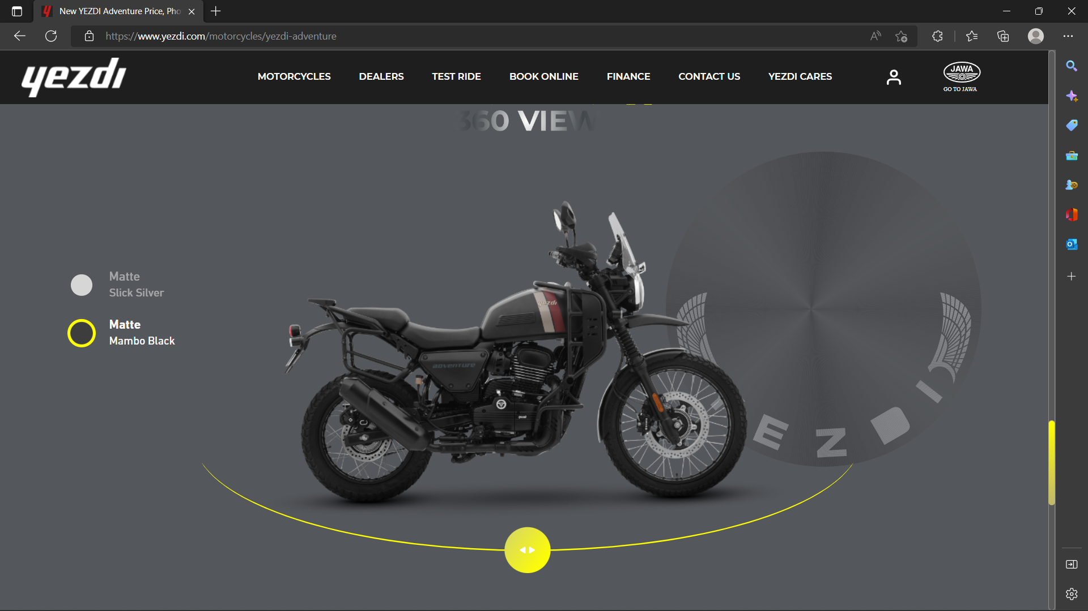
2. ENGINE

ENGINE CAPACITY

334 cc

ENGINE TYPE

SINGLE CYLINDER, 4 STROKE, LIQUID COOLED, DOHC

MAX POWER

22.29 kW

MAX TORQUE

29.84 Nm

FUEL SYSTEM

ELECTRONIC FUEL INJECTION

COMPRESSION RATIO

11:1

BORE STROKE

81 X 65 mm

EXHAUST

SINGLE SIDE EXHAUST

* DIMENSION AND WEIGHT

WEIGHT

198 kg

FUEL TANK CAPACITY

15.5 L

WHEELBASE

1465 mm

SEAT HEIGHT

815 mm

* TRANSMISSION

GEAR BOX

Constant mesh, 6 speed

* CHASSIS AND SUSPENSION

FRAME

DOUBLE CRADLE

FRONT SUSPENSION

TELESCOPIC FORKS, ø 41 mm

REAR SUSPENSION

MONO SHOCK ABSORBER WITH LINKAGE & 7-step ADJUSTABLE PRE-LOAD

* BRAKING

FRONT BRAKE TYPE

DISC WITH FLOATING CALIPER AND ABS

REAR BRAKE TYPE

DISC WITH FLOATING CALIPER AND ABS

FRONT DISC SIZE

320 mm

REAR DISC SIZE

240 mm

* WHEEL AND TYRES

FRONT TYRE

90/90-21, 54S

REAR TYRE

130/80-17, 65S